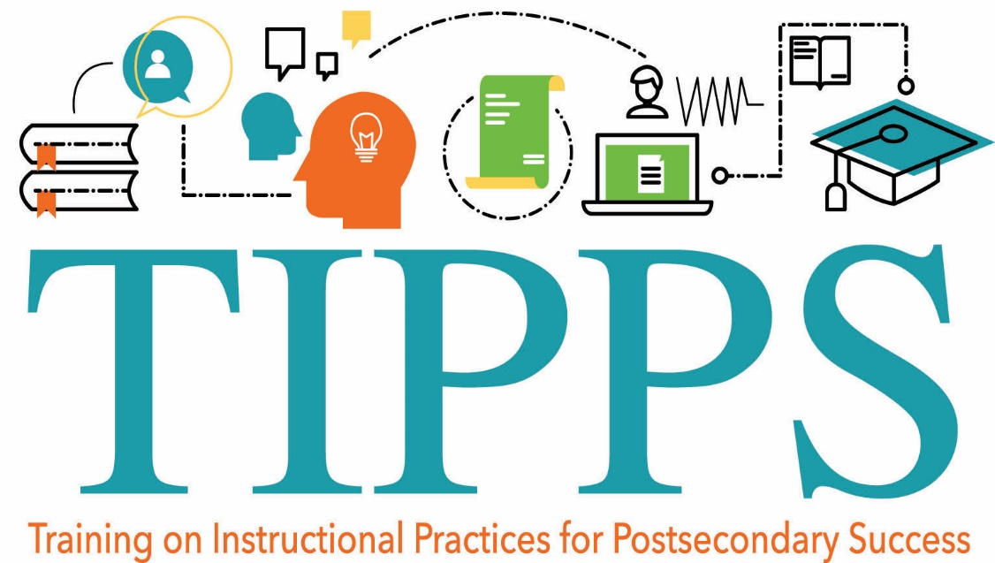
TIPPS Reflection Guide

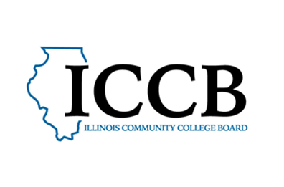
Training on Instructional Practices for Postsecondary Success
Practical Application 1 – Planning for Professional Learning
(To be completed following Module 1)

Consider the following questions as you prepare to proceed with the TIPPS module series.

- Review the learning objectives for the series:
- Create student-centered learning conditions by eliminating barriers to learning and promoting competencies for a supportive climate.
- Explore a curricular framework that embraces student variability and increases equity in the learning process.
- Engage students with evidence-based instructional practices designed to increase authentic learning that is both rigorous and relevant.
- Incorporate effective assessment and feedback practices to support students’ mastery of their learning goals.

Now, reflect: What aspect of these objectives are you most excited about? On what topic do you have the most to learn? Specifically, what do you hope to gain to enhance your teaching practice and your students’ success?

- The remaining practical application activities in the series will allow the opportunity to apply what you’ve learned one academic unit at a time. Is there a unit or two that you would like to focus on strengthening?

- Use this space to plan for successful completion of the TIPPS module series.

When can you schedule time to complete the modules? List dates and times.

Where can you work without interruption?

Who can you connect with to discuss the modules and your goals for application?

How can you celebrate the completion of each module in a way that motivates you?

Training on Instructional Practices for Postsecondary Success
Practical Application 2 – Reducing Barriers, Strengthening Supports
(To be completed following Module 2)
Choose a unit of instruction in your course that you would like to enhance and strengthen. This will be your unit of focus throughout the TIPPS series.
Answer the following questions related to that unit. If helpful, focus on one lesson at a time when completing this thought exercise. This is a brainstorm. There are no right or wrong answers!
Unit or lesson:
Learning objectives: what should students know and be able to do upon completion of the unit/lesson?

List specific activities that students are asked to engage in to meet the learning objectives.  Be specific.  Examples: Students…  Read and comprehend the text. Listen to lecture. Follow instructions from a video. Engage in specific software. Use a specific tool. Work in a group. Present findings. Etc.  List each activity below in a separate box in this column. | What potential barriers in the classroom environment could prevent your students from successfully engaging in each activity?  For instance, can all material be accessed visually, audially, and physically by all students?  Do all students have access to internet or items needed to complete the work?  Is the social climate of the classroom conducive to sharing ideas? | What learning supports (things you can do or provide as an instructor) could alleviate or eliminate these barriers?  These learning supports may be simple or more involved. They may be academic or social/emotional in nature.  Focus on supports that can be provided on the instructional level in the classroom (although other relevant supports may be provided on the larger system level.)
Example:  Students refer to instructions on a whiteboard while completing tasks in the lab. | Example:  The white board might not be visible for all students. | Example:  A written copy of instructions could be provided.
Example:  Students read each other’s papers and provide verbal feedback.  Activity: | Example:  Students may not have practice and/or feel comfortable providing constructive feedback.  Possible barriers to learning: | Example:  Sentence starters for sharing constructive feedback could be taught explicitly before engaging in peer feedback.  Possible learning supports:

Now consider the learning supports listed in the right-hand column above.
- Which supports ensure a physically and socially/emotionally safe and accessible learning climate?

- Which supports aid the explicit development of student competencies and skills, both academic and social/emotional?

- Which supports stem from the learning needs of some students, but if done universally, could potentially benefit all students?
Training on Instructional Practices for Postsecondary Success
Practical Application 3 – Applying a Universal Design for Learning
(To be completed following Module 3)
In the Practical Application for Module 2, you began to consider how to proactively create conditions for learning and address environmental barriers to learning. This was a general brainstorm, and you will continue toward the same goals here. Specifically, consider how Universal Design for Learning (UDL) can make the learning environment more engaging and accessible for all students.

Again, we will apply what you’ve learned to planning for a specific unit or lesson (the same considered in the last module). Use the UDL Guidelines to explore how you can address barriers and allow students to flexibly meet the learning objectives.

Choose just a few of the UDL checkpoints on the next three pages and note specifically how you could adapt your lesson to provide multiple means for engagement, representation, action and expression.

Work in this document electronically so that you may click the hyperlinked checkpoints for ideas and create more space for notes.

Unit or lesson (same as Practical Application 2):

Reconsider the learning objectives of the unit or lesson. Knowing what you know from Module 3, you may want to revise them. The learning objectives should begin with an action verb and describe what students should be able to do as a result of new learning. Learning objectives for the unit or lesson:

Think about what you observe in your classroom. How might you increase student success by providing flexibility in regard to engagement, representation, action and expression? Choose a small number of guidelines to start. Click to read suggestions on the hyperlinked CAST website. Then, think specifically about how you might enhance the learning experience in regard to the chosen unit/lesson. Capture your thoughts in the right-hand column on the following pages.

UDL Checkpoints: | What adaptations might you make related to each selected checkpoint?

Provide Multiple Means for Engagement:

Provide options for recruiting interest

7.1 Optimize individual choice and autonomy

7.2 Optimize relevance, value, and authenticity

7.3 Minimize threats and distractions

Provide options for sustaining effort and persistence

8.1 Heighten salience of goals and objectives

8.2 Vary demands and resources to optimize challenge

8.3 Foster collaboration and community

8.4 Increase mastery-oriented feedback

Provide options for self-regulation

9.1 Promote expectations and beliefs that optimize motivation

9.2 Facilitate personal coping skills and strategies

9.3 Develop self-assessment and reflection

UDL Checkpoints continued: | What adaptations might you make related to each selected checkpoint?
Provide Multiple Means of Representation:

Provide options for perception

  - Offer ways of customizing the display of information

  - Offer alternatives for auditory information

  - Offer alternatives for visual information

Provide options for language, mathematical expressions, and symbols

2.1 Clarify vocabulary and symbols

2.2 Clarify syntax and structure

2.3 Support decoding of text, mathematical notation, and symbols

2.4 Promote understanding across language

2.5 Illustrate through multiple media

Provide options for comprehension

3.1 Activate or supply background knowledge

3.2 Highlight patterns, critical features, big ideas, and relationships

3.3 Guide information processing, visualization, and manipulation

3.4 Maximize transfer and generalization

UDL Checkpoints continued: | What adaptations might you make related to each selected checkpoint?

Provide Multiple Means for Action and Expression:

Provide options for physical action

4.1 Vary the methods for response and navigation

4.2 Optimize access to tools and assistive technologies

Provide options for expression and communication

5.1 Use multiple media for communication

5.2 Use multiple tools for construction and composition

5.3 Build fluencies with graduated levels of support for practice and performance

Provide options for executive functions

6.1 Guide appropriate goal setting

6.2 Support planning and strategy development

6.3 Facilitate managing information and resources

6.4 Enhance capacity for monitoring progress

Reflect: What are you discovering about UDL as you practice applying the framework?

Applying a Universal Design for Learning is a continual process. Keep this tool handy as you revisit this unit/lesson and consider other units/lessons in your planning.
Training on Instructional Practices for Postsecondary Success
Practical Application 4 – Rigor and Relevance
(To be completed following Module 4)
Consider this information on rigor and relevance. Complete the reflective questions that follow.
Rigor calls for student work that moves beyond the mere reproduction of information to the construction of knowledge. This requires students to do more than summarize or paraphrase information; students use what they already know to create or explore new ideas through interpretation, analysis, synthesis, or evaluation of information. Rigor emphasizes elaborated communication and asks students to make assertions and support them with evidence.

Relevance emphasizes real-world applications, prompting students to go beyond the demonstration of academic competence to achieve real-world purposes and submit their work to real audiences other than the teacher or other students. Relevance also calls on students to make choices about what they will study and how they will demonstrate mastery.

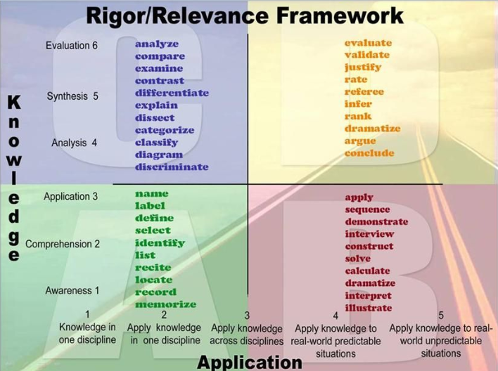Image based on the Rigor Relevance Framework by the International Center for Leadership in Education
Consider the unit or lesson that has been the focus of Practical Applications 2 and 3.
Unit or lesson (same as Practical Application 3):
Learning objectives (same as Practical Application 3):

Brainstorm multiple ways in which you could increase the rigor of the unit. How can you move from student awareness and comprehension to then require students to apply, analyze, synthesize, create, and/or evaluate?

Brainstorm multiple ways in which you could increase the relevance of the unit. How could you facilitate the opportunity for your students to apply their learning to real-world situations?

What resources and action steps are required to make these changes?

Do these changes require reconsideration or revision of the learning objectives? How so?

Repeat this exercise for various units. Similar strategies to increase rigor and relevance can be applied across units as you establish course routines and expectations.
Training on Instructional Practices for Postsecondary Success
Practical Application 5 – Assessment Inventory
(To be completed following Module 5)

Consider the same unit that has been your focus for practical Applications 2-4. Complete the following chart evaluating the assessments for this unit, then consider the reflective questions that follow. Repeat this process for all units in your course.
Unit (same as Practical Application 4):
Learning Objectives (same as revised objectives from Practical Application 4):

Assessment: | What is the general purpose of this assessment, and is it best categorized as formative, interim, summative? | If it is formative, are the results used to inform your teaching? How? | If it is formative, are results shared as individual feedback for students in a time and manner that can inform their learning? How? | What learning objectives (skills and knowledge) are measured by this assessment, and how do you ensure that it does so? | What can you do to ensure that all students can access and engage in the assessment and demonstrate their learning? | What is your intention regarding this assessment: to keep it, change it, change how you use results, or stop administering it?
Example:  Exit slip following lab | Formative | Yes, I review them to see what I need to clarify before the next lab. | No, I do not share results with students individually or as a whole. | The slip is meant to measure the same learning goals as the lab, but some questions do not align since I changed the lab. | Leave more time to complete the slip at the end of class. Some students don’t have enough time to show what they know. | Keep it but start sharing results with students so they may use it to set learning goals.  Also, revise to better reflect learning objectives.
Assessment: | What is the general purpose of this assessment, and is it best categorized as formative, interim, summative? | If it is formative, are the results used to inform your teaching? How? | If it is formative, are results shared as feedback for students in a time and manner that can inform their learning? How? | What learning objectives (skills and knowledge) are measured by this assessment, and how do you ensure that it does so? | What can you do to ensure that all students can access and engage in the assessment and demonstrate their learning? | What is your intention regarding this assessment: to keep it, change it, change how you use results, or stop administering it?

Assessment: | What is the general purpose of this assessment, and is it best categorized as formative, interim, summative? | If it is formative, are the results used to inform your teaching? How? | If it is formative, are results shared as feedback for students in a time and manner that can inform their learning? How? | What learning objectives (skills and knowledge) are measured by this assessment, and how do you ensure that it does so? | What can you do to ensure that all students can access and engage in the assessment and demonstrate their learning? | What is your intention regarding this assessment: to keep it, change it, change how you use results, or stop administering it?
Questions to Inform Assessment Design
- Does the assessment measure the knowledge and skills it is intended to measure?

- Do assessment methods or required technologies interfere with the demonstration of knowledge and/or require explicit instruction?

- Are students provided multiple options for demonstrating their learning?

- Are students provided opportunities to demonstrate higher order thinking?

- Do aspects of the assessment pose barriers for the demonstration of knowledge by students with visual, auditory, motor, cognitive, or other disabilities?

- What technology and/or resources needed for completion of assessments may pose barriers to accessibility?

- Do aspects of the assessment pose barriers for the demonstration of knowledge by English Language Learners?

- What aspects of course assessments may indicate cultural bias?

Training on Instructional Practices for Postsecondary Success
Planning for Implementation
(To be completed in Module 6)

You are to be commended for completing the Training on Instructional Practices for Postsecondary Success! TIPPS was designed to provide a broad overview of evidence-based teaching practices so that you may continually add tools to your professional toolbox.
The goal is continuous improvement! Recognizing that you are already possess skills as a professional and educator, there is always room to grow. As you refine and/or adopt practices, it is important to remember that change happens in small steps and requires time to become engrained. You may use this tool to focus your implementation efforts as you move forward.

- Consider data (from your observations, student assessment, student feedback, etc.) related to the following aspects of your courses: conditions for learning and learning supports, curriculum, instruction, assessment, and feedback.

What data points indicate a need to adjust practice for increased student success?

- Considering the above data and your knowledge of your students and course(s), is there a particular aspect of your teaching practice on which you would like to focus next?

- Creating optimal conditions for learning for all students
- Designing an accessible curriculum that accounts for learner variability
- Applying engaging instructional practices that promote rigor and relevance
- Using assessment and feedback to inform learning
- Other?

What data and observations support this particular focus?

- Within the focus area you have chosen, brainstorm specific evidence-based practices (strategies) that you feel would enhance your course(s) and support student success. Refer back to the modules and suggested resources to revisit recommended practices.

- From your brainstorm, create a small number of specific goals to pursue moving forward. A manageable number will depend on your available time and the requirements of the goals. Be as specific as possible.
Some goals may pertain to the direct implementation of an evidence-based practice. Example: Incorporate more opportunities for self-reflection in student coursework.
Some goals may pertain to your own professional learning. Example: View a webinar series on UDL to better understand how to use the framework in curriculum design.
Consider your goals in time frames: For example, you might list an immediate task to complete in the next 3 months, a related shift in practice to implement with the start of the next semester, and the overall implementation goal you would like to fully engrain in your practice over the next year or two.
This chart may help:
Evidence-based Practice | Task(s) to complete in the next 3 months | Shifts in practice to implement in the next semester | Practice to be fully implemented over the next year or two

- When you are comfortable with how you have charted a small number of goals over time, revisit those goals with this question in mind: What will be the indicator(s) of your success? Monitoring your implementation goals is an important step not to be overlooked! Be specific when considering, what data will you measure to assess the success of your efforts?
For example, if you have a professional learning goal to study a resource, the measure of your success will be to complete that task.
If you have an implementation goal of providing various methods for students to practice and apply a certain skill, you will track both your efforts in providing those opportunities and your students’ success in mastering the skill.
Brainstorm, what indicators will you measure to assess both your efforts and how your efforts are impacting student outcomes? Again, a simple chart may help.

Goals related to an Evidence-Based Practice | How will you monitor your efforts and measure success in relation to student outcomes?

- Who can be an accountability partner for you in your efforts? Can you inform a mentor or supervisor about this focus related to your professional development? Is there a colleague or group of colleagues focused on similar goals? Is there a community of educators discussing this practice area online? How can you ensure support over time?

- Last, what is your plan to continually revisit and measure progress toward your goals? Set a timeline for when you will check-in on your efforts. Will you revisit this in a couple weeks, a few months, at the start or next semester? Schedule reminders for these check-ins with yourself and your accountability partner(s) so that your intentions are not lost in a full schedule of commitments. Also, remember to celebrate your successes!

CONGRATULATIONS!

This completes the guided planning portion of TIPPS and concludes the TIPPS modules. That does not mean the learning must end. Revisit the TIPPS modules as often as you like to reconsider a topic with new understanding or dig deeper into suggested resources.
Contact the Illinois Center for Specialized Professional Support with feedback or questions.
Congratulations on your ongoing commitment to professional learning!

Training on Instructional Practices for Postsecondary Success
Illinois Center for Specialized Professional Support
Illinois Community College Board
icsps.illinoisstate.edu

